Math 4 Honors Name ________________________________

Lesson 5-3: *Order & Repetition II* Date _______________________________

**Learning Goals:**

* *I can identify similarities and differences between permutations and combinations.*
* *I can apply the appropriate strategies and formulas in counting situations, not involving repetitions, where order is important and where order is not important.*

1. General Formulas:  and 

a. Both *n* and *k* must be non-negative integers, with *n* _____ *k*.

b. i. Show formula work and do *without* calculator: *P*(9, 2) = _______ *C*(9, 2) = _______

ii. Show calculator notation – use calculator features: *P*(9, 2) = _______ *C*(9, 2) = _______

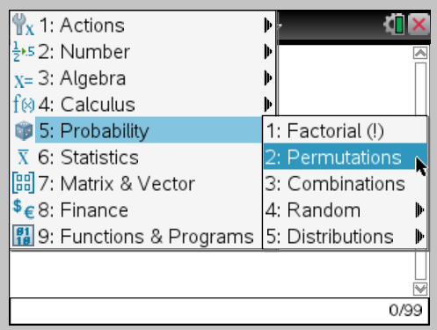

c. Formula:

2. Simply read through the italicized part of a and b as a summary of what happens when using permutations

and combinations. See how the description fits the formulas.

3 a. ___________________________ different hands can be made. Show work.

b. They can be filled in _____________________ different ways. Show work.

c. There are ____________________ different ways for win, place, and show. Show work.

d. i. There are ____________________ different bytes possible. Show work.

ii. There are __________________ eight-bit strings that contain two zeroes. Show work.

4. There are _____________ subsets. Show work.

OVER 🡪

5 a. Give an example:

b. Formula: _________ Enter the formula into the appropriate cell of the table below.

|  |  |  |
| --- | --- | --- |
|  | No Repetitions | Repetitions OK |
| Different Orders Count as Different Possibilities |  |  |
| Different Orderings Do Not Count as Different Possibilities |  |  |

6. Since repetition is allowed, the 3-side-dish choices (*are/are not*) _______________ examples of

combinations or permutations. Enter “side-dish choices” into the appropriate cell of the table above.

